User Interface Design
Quick Grad Planner
Customer: Dr. John Callahan

South Pole Tigers

Payal Aggarwal
Heather Long
Christopher Stark
Emmanuel Tebong
Patrick Trinkle

November 1, 2005

Quick Grad Planner by South Pole Tigers
User Interface Design

Table of Contents

Page

1. Introduction 2

  - Purpose of This Document 2
  - References 2

2. User Interface Walkthrough 3

2.1 Overview of user interface 3
2.2 Screen Images 4

3. Data Validation 18

4. Report Formats 19

Appendix A – Peer Review Sign-off 20

1. Introduction
  - Purpose of This Document
The purpose of this document is to present to the customer a detailed view of what the user interface of the final product is going to look like. The user interface design document will function as a UI manual to guide the customer through screen by screen, thereby helping the customer navigate through the system and showing him what each screen does.

  - References

The following is a list of references used when compiling this document.

Quick Grad Planner System Requirements Specification, South Pole Tigers, October 31, 2005

UI Design Template, Susan Mitchell
http://www.csee.umbc.edu/courses/undergraduate/345/fall05/mitchell/Templates/uiTemplate.doc, October 31, 2005

2. User Interface Walkthrough

2.1 Overview of the user interface

Below is an overview diagram of a user’s flow through the user interface. For pictures of each component, see Section 2.2 below.

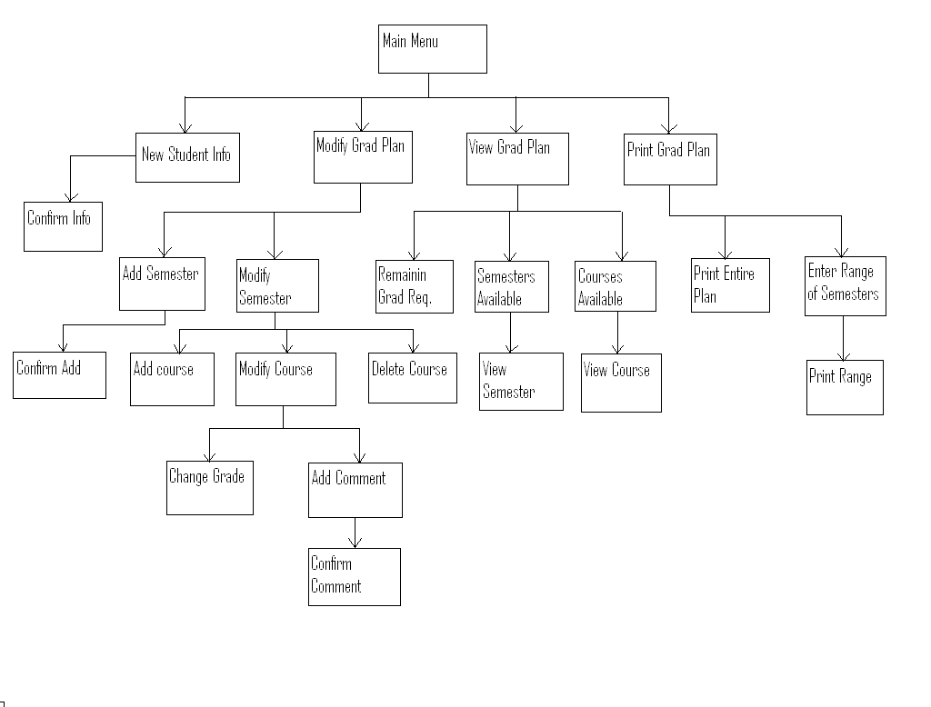

Figure A. – User Interface Overview

2.2 Screen Images

The purpose of the application is to help students plan their semesters ahead of time in order to graduate as quickly as possible. The user interface for the Quick Grad Planner will be text based.

When the program starts; the student is presented with a menu of options related to his/her Graduation Plan, see Figure 0.

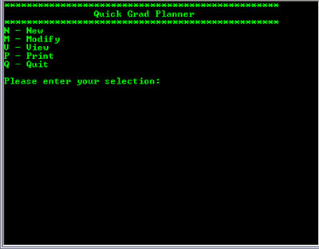
Figure 0 Main Menu

The student has five options. He/She can create a new Graduation Plan, modify a current Graduation Plan, view information about their Graduation Plan, print out their Graduation Plan, or quit the program.

The student selects “N.” A new screen appears prompting for the student’s name; first then last. The program then prompts the student for the beginning semester, year, and major see Figure 1.

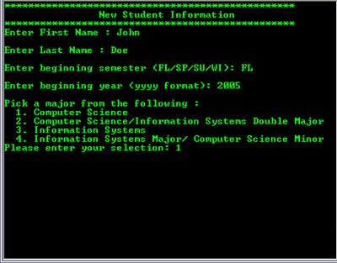
Figure 1.0 New Student Information Screen

The entered information is then displayed on the screen below the menu prompting for the student to check accuracy of the information before continuing, see Figure 1.1

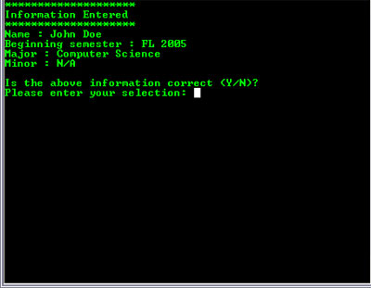
Figure 1.1 New Student Information Confirmation Screen

The student can select either ‘Y’ or ‘N’, to either save the information as correct or go through the process again from the New Student Information Screen, see Figure 1.0. If the student selects ‘Y’ for Yes, the student is sent back to the Main Menu, see Figure 0.

The student selects ‘M’ for modify. A new screen appears with a menu and a prompt for the student to select one of the options. The options are: Add Semester; Modify Semester; and Back. At this screen the student can add a semester to the Graduation Plan, modify a semester already in the Graduation Plan, or return to the Main Menu (see Figure 0). See Figure 2 for this menu screen.

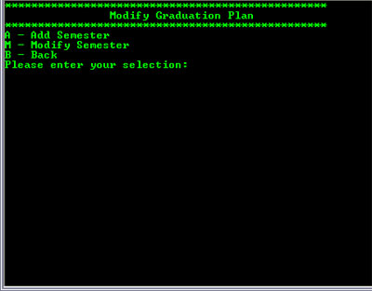
Figure 2 Modify Graduation Plan Menu

The student selects ‘A’ to add a semester to the Graduation Plan. A new screen appears prompting the student for the semester designator, i.e. Fall, and the year of the semester, see Figure 2.1.0.

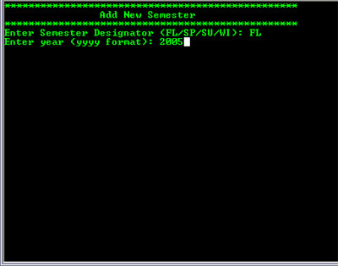
Figure 2.1.0 Add Semester Prompt

The program then displays the information regarding the new semester to the student and prompts for confirmation of accuracy, see Figure 2.1.1

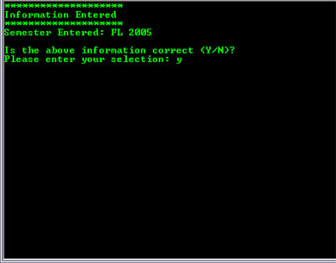
Figure 2.1.1 Confirmation of Semester Addition Screen

The student selects ‘N’ and is prompted for the information until they choose “Y.” The student selects ‘Y’ and is returned to the Modify Graduation Plan Menu, see Figure 2.

The student selects ‘M’ from the Modify Graduation Plan Menu (Figure 2), and the Modify Semester Menu is displayed, see Figure 2.2.0. The student has the following options: add a course; delete a course; modify a course; or return to the Modify Graduation Plan Menu (Figure 2).

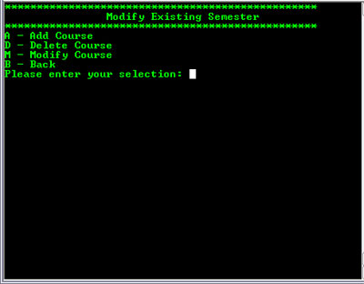
Figure 2.2.0 Modify Semester Menu

The student selects ‘A’ to add a course. The program displays a list of available courses and prompts the student to choose a course to add. Once the student selects a course from the list the student is asked to confirm, see Figure 2.2.1.

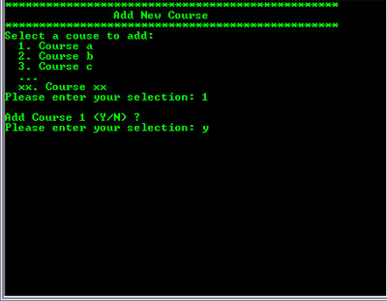
Figure 2.2.1 Add Course Selection & Confirmation Prompt

After the student confirms the information they are returned to the Modify Semester Menu (Figure 2.2.0).

The student selects ‘D’ from the Modify Semester Menu (Figure 2.2.0). The program displays a list of courses available for deletion and prompts the student to make a selection. Once the student makes a selection the program prompts for confirmation, see Figure 2.2.2. The program will prompt for the information until the student selects ‘Y,’ then the program returns to the Modify Semester Menu (Figure 2.2.0).
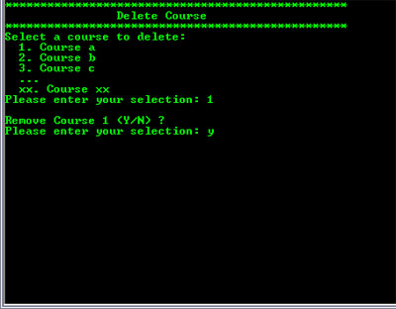
Figure 2.2.2 Course Deletion & Confirmation Prompt

The student selects ‘M’ for “Modify Course.” The program lists available courses for modification and prompts the student for a selection. Once the student selects a course, the program prompts the student to select which attribute of the course they would like to modify, see Figure 2.2.3.

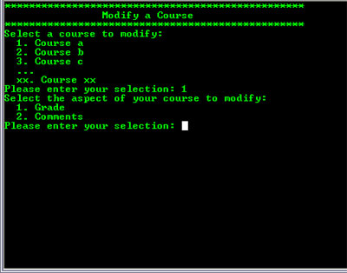
Figure 2.2.3 Course Modification Selection

The student selects 1 from the Course Modification Selection Screen (Figure 2.2.3). The program prompts the student to enter a new grade, see Figure 2.2.3.1. The student is prompted for confirmation.

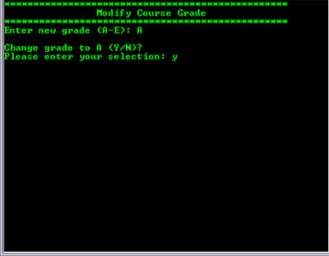
Figure 2.2.3.1 Modify Course Grade Attribute Prompt

The student is returned to the Course Modification Selection Screen (Figure 2.2.3), and follows the prompts. The student selects 2 from the Course Modification Selection Screen (Figure 2.2.3). This screen prompts the student to enter new comments for the course, see Figure 2.2.3.2a. The program then displays the comment back and prompts for confirmation of the input, see Figure 2.2.3.2b.

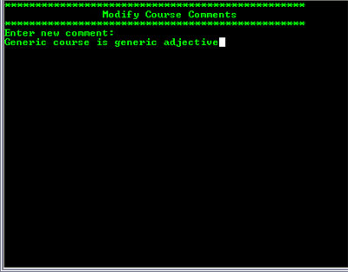
Figure 2.2.3.2a New Course Comments Input Screen

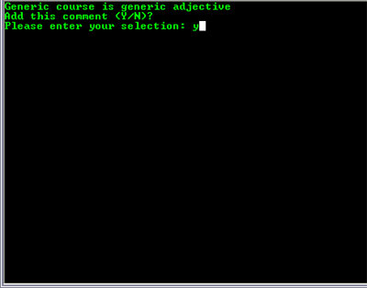
Figure 2.2.3.2b New Course Comments Confirmation Screen

The student selects ‘V’ from the Main Menu (Figure 0). The program displays the View Graduation Plan Menu, see Figure 3. The student has the following options: View Remaining Graduation Requirements; View a Selected Semester; or return to the Main Menu (Figure 0).

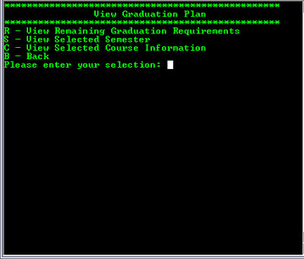
Figure 3 View Graduation Plan Menu

If the student selects ‘R,’ the program displays the remaining courses required to graduation based on the student’s major. See Figure 3.1. The student inputs ‘B’ and the program returns to the View Graduation Plan Menu (Figure 3).

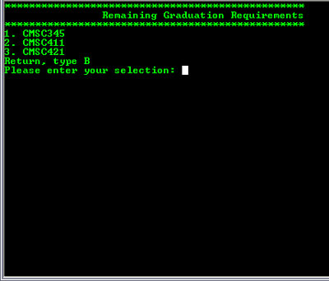
Figure 3.1 Remaining Graduation Requirements Screen

If the student selects ‘S,’ the program displays all semesters in the system and prompts the student for the desired semester, see Figure 3.2.

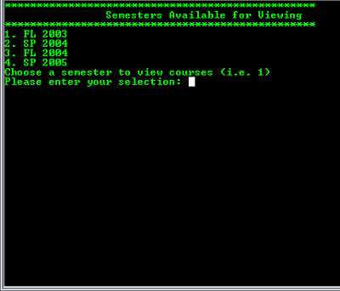
Figure 3.2 View Semester Menu

The student selects a semester listed and the program displays all the courses for the semester, see Figure 3.2.1. The student types ‘B’ and the program returns to the View Graduation Plan Menu (Figure 3).

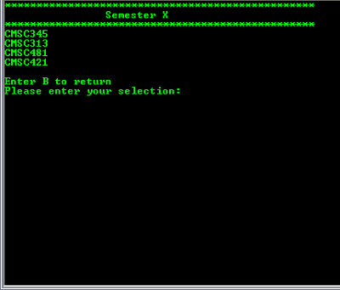
Figure 3.2.1 Selected Semester Course List

The student selects ‘C’ from the View Graduation Plan Menu (Figure 3). This displays a list of courses, from which the student will select one, see Figure 3.3.

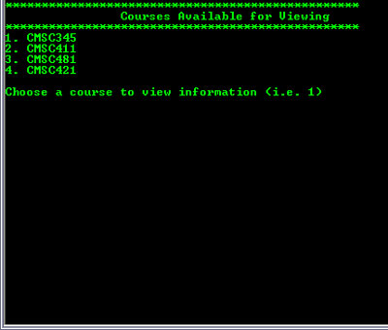
Figure 3.3 Course List Screen

The student selects a course and the program displays the attributes of the course, title, grade, and comments, etc, see Figure 3.3.1. The student inputs ‘B’ and the program returns to the View Graduation Plan Menu (Figure 3).

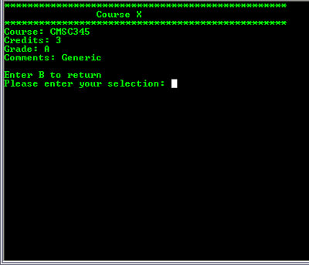
Figure 3.3.1 Selected Course Information Screen

The student selects ‘P’ from the Main Menu (Figure 0). The program displays the Print Selection Menu (Figure 4). The student has the following options: Print Entire Plan; Print a Range of Semesters; return to Main Menu (Figure 0), see Figure 4.

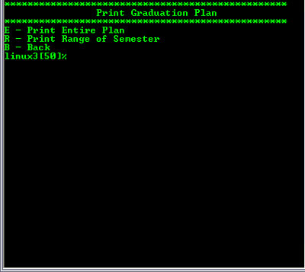
Figure 4 Print Selection Menu
If the student selects ‘E’, to Print the entire Graduation Plan, text appears stating that the job has been sent to the default printer. See Figure 4.1.

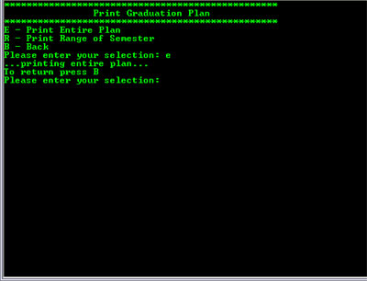
Figure 4.1 Print Entire Graduation Plan Screen

If the student selects ‘R’, to print a range of semesters, the system prompts for the range of semesters to be printed. See Figure 4.2.1. Then text is displayed stating that the entered range is being printed. See Figure 4.2.2.

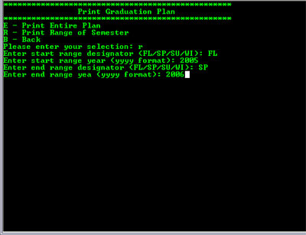
Figure 4.2.1 Print Range Prompts

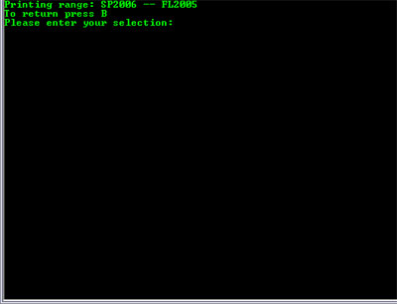
Figure 4.2.2 Print Range Feedback Screen

The student can select ‘B’ to return to the Main Menu (Figure 0).

- Data Validation

The following shows all the information that is entered at the command prompt by the user. Each piece of data is described by which figure in this document it is in, data type, limits on the data, its format, and a brief description of the data.
Name | Figure | Data Type | Limits | Format | Description
First Name | 1.0 | String | Min len =1. max len=32 | Alphabetic, “-“, and “ “ | Student’s First Name
Last Name | 1.0 | String | Min len =1. max len=32 | Alphabetic, “-“, and “ “ | Student’s Last Name
Semester | 1.0, 2.1.0, 4.2.1 | String | FL, WI, SU, SP | Two capital letters | Semester code
Year | 1.0, 2.1.0, 4.2.1 | Integer | Value > 0 | YYYY | Year code
Comment | 2.2.3.2a | String | Min len = 0, Max length = 256 | Alphanumeric | Comment for courses
Grade | 2.2.3.1 | Char | A,B,C,D, or F | Capital letter | Student’s grade for the course
Main Menu Selection | 0 | Char | N, M, V, P, Q | Capital letter | Selection from main menu
List Selection | 1.0, 2.2.1, 2.2.2, 2.2.3, 3.2, 3.3 | Integer | Value > 0 | Positive number | Selection from a list
Modify Menu Selection | 2 | Char | A, M, B | Capital letter | Selection from Modify Menu
Modify Semester Menu Selection | 2.2.0 | Char | A, D, M, B | Capital letter | Selection from Modify Semester Menu
View Graduation Plan Menu Selection | 3 | Char | R, S, C, B | Capital letter | Selection from View Graduation Plan menu
Print Menu Selection | 4 | Char | E, R, B | Capital letter | Selection from Print menu
Yes or No | 1.1, 2.1.1, 2.2.1, 2.2.2, 2.2.3.1, 2.2.3.2b | Char | Y, y, N, n | Letter | Yes or No selection
Back | 3.1, 3.2.1, 3.3.1, 4.1, 4.2.2 | Char | B, b | Letter | Selection will take user to previous screen

- Report Format

The following is an example of the hard copy the software will print. It shows the selected semesters in the course plan, the courses in that semester, along with the number of credits for the course, the grade, and any comments the user has entered.

 | John Doe Graduation Plan Fall 2005 - Fall 2006
 | Semester: Fall 2005
 | Course | Credits | Grade | Comments
 | CMSC 202 | 4 | A
 | CMSC 203 | 3 | A | Here is a comment.
 | AH | 3 | B
 | SS | 3 | A
 | Semester: Spring 2006
 | Course | Credits | Grade | Comments
 | CMSC 341 | 3
 | CMSC 451 | 3
 | CMSC 442 | 3
 | AH | 3
 | Semester: Fall 2006
 | Course | Credits | Grade | Comments
 | CMSC 345 | 3
 | CMSC 411 | 3
 | CMSC 421 | 3
 | SS | 3

Appendix A – Peer Review Sign-off

This is to denote and confirm that all members of the Quick Grad Planner team have seen and approved this UI design document, that it meets their standards of excellence and conveys the information that was agreed upon and will be done in the project. We the undersigned agree and confirm that the document above is our own work and approve of its contents with any additional comments to be noted upon signing.
______________________________________________________
Payal Aggarwal

______________________________________________________

Heather Long
______________________________________________________

Christopher Stark
______________________________________________________

Emmanuel Tebong
______________________________________________________

Patrick Trinkle
______________________________________________________
Team Member Comments:

